Jackie Madrid
Room 139
jacquelinemadrid@ccusd.org
Course Syllabus
8th Grade Spanish Immersion Social Studies-U.S. History
2017-2018

Welcome to an exciting year of 8th Grade Social Studies! I am so grateful to be your teacher. I look forward to working with you this year to strengthen your scholastic talents as you continue on the road to college and career readiness. Please carefully review the expectations and requirements for this course.

Course Overview
This course will cover United States History and Geography from the Colonial Era to Post-Civil War Reconstruction, with an emphasis on building literacy skills, critical thinking, and civic responsibility.
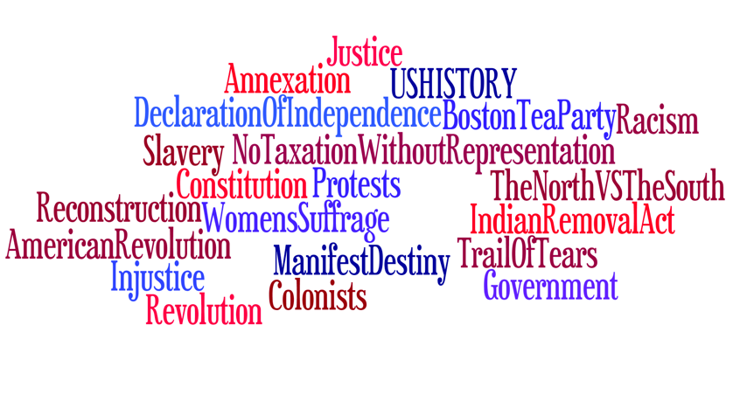
Content Covered
· American Colonial Era
· American Revolution
· U.S. Constitution
· Early American Politics
· Westward Expansion
· Civil War
· Reconstruction

Essential Skills
· Reading & Annotation of Primary and Secondary Sources, Document-Based Questioning
· Research Methods & Evaluation
· Comparative Histories/Multiple Perspectives
· Thematic Connections Between Past and Present
· Written & Oral Argument

Classroom Rules
In an effort to establish a safe and comfortable learning environment, all students are expected to abide by the following rules:
1) Treat others with respect and consideration.
2) Listen to the teacher attentively and follow directions.
3) Actively participate in classroom activities and discussions.
4) Maintain academic integrity and strive for success.

Rules Enforcement
If classroom rules are not followed, the following consequences will be enforced:
1) Verbal warning with name on the board
2) Name on board with a check next to their name and discussion with teacher
3) Name on board, two checks next to name, seat change and parent notification
5) Referral to Assistant Principal's Office

Classroom Procedures
- Students will be expected to be in their seats before the bell rings! Entering the class as the bell is ringing is considered being late to class. The day begins with a Warm‑Up activity. The Warm-Ups will be collected and checked on a regular basis. The agenda for the day is posted at the front of the room. Daily classroom activities will vary and include individual, partner, and group assignments. Students are personally responsible for recording any homework assignments and/or upcoming exams in their Time Trackers. Class will end with an Exit Ticket based on the lesson. Exit Tickets are used to determine effectiveness of the lesson and personal needs of the individual students.
Homework
- Homework consists of work not completed in class, as well as reinforcement of skills taught in class. If no homework is assigned, the student is expected to review and study work in progress. Homework assignments will be posted at the front of the room as well as online through the CCMS website.
Late Work
In alignment with the policies of the Culver City High School Social Studies Department, late work will not be accepted this year. Late work will only be accepted and graded for full credit in cases of excused absences, family emergencies, or in compliance with IEPs and 504 Plans. Students are required to make-up work missed during an excused absence in the amount of time they were absent. For example, if a student is out sick for 2 days, they have 2 days to complete all missed work for full credit. After those two days, late homework will not be accepted.

Use of cell phones / tablets
School policy on cell phone use will be observed in the classroom. In some cases, students will be allowed to use cell phones for class activities. Teacher will explicitly inform students on these occasions.

Media
In some cases, teacher will play clips, movies, YouTube videos, etc. I will be very selective and thoughtful about media choices, but if you have any concerns please let me know ASAP.

- Materials Needed
  - Composition Book (College Ruled Preferred)
  - Time Tracker
  - 3 Ring Binder (A tab for history class will do)
  - Pencils
  - Pens in Blue or Black Ink
  - Highlighter or colored pen
  - Would be nice but not required: Colored pencils, pair of scissors, glue stick and a dry erase marker. A class set will always be available.

Assessment
Students will have an opportunity to show their learning progress in a variety of different assessments. In addition to the traditional testing methods, students will be required to express their learning and ability to apply knowledge in the form of creative projects, presentations, and writing assignments.

Grades will be based on an overall assessment of:
1) Assignments: in-class activities, student collaboration, presentations, homework (40%)
2) Summative Assessments: quizzes, tests, projects, and writing assignments (60%)

Grade Scale Ranges
A = 89% to 100%
B = 79% to 88%
C = 69% to 78%
D = 59% to 68%
F = 58% and below

Citizenship and Work Habits
The Citizenship and Work Habit grades will be assessed using the school wide accepted Citizenship And Work Habits Rubric located in the your Time Tracker. Students should use the time-tracker calendar to write down all assignments, tests and projects. If student receive good Citizenship And Work Habit grades, they earn eligibility for field trips, scholarships league, or certain classes, etc. On the other hand, if they receive poor Citizenship and Work Habit grades, they lose the privileges above.

Please feel free to contact me at any time throughout the school year with questions or concerns. Please keep this letter as a reference if any questions arise or if you need to contact me. Please sign, remove and return the attached paper indicating that you have read and understand the class syllabus.

Thank You,
Jackie Madrid

-----------------------------------------------------------------------------------------------------------------------
I have read the class syllabus and understand the course expectations and requirements for Ms. Madrid’s 8th Grade Spanish Immersion Social Studies course. Also, I will keep the syllabus for reference throughout the course.

Print Student’s Name ___________________________________________
Student’s Signature ___________________________________________

Print Parent’s Name ___________________________________________
Parent’s Signature ___________________________________________

